**Business Question and Visualization Report**

|  |  |
| --- | --- |
| Date | 19 March 2025 |
| Team ID | LTVIP2025TMID19942 |
| Project Name | Cosmetic Insights : Navigating Cosmetics Trends and Consumer Insights with Tableau |
| Maximum Marks | 5 Marks |

Visualization development refers to the process of creating graphical representations of data to facilitate understanding, analysis, and decision-making. The goal is to transform complex datasets into visual formats that are easy to interpret, enabling users to gain insights and make informed decisions. Visualization development involves selecting appropriate visual elements, designing layouts, and using interactive features to enhance the user experience. This process is commonly associated with data visualization tools and platforms, and it plays a crucial role in business intelligence, analytics, and reporting

**Business Questions and Visualisation**

The process involves defining specific business questions to guide the creation of meaningful and actionable visualizations in Tableau. Well-framed questions help in identifying key metrics, selecting relevant data, and building visualisation that provide insights.

**Sample**

1. **What are the market shares of the top beauty brands?**

* ***Visualization:*** Pie chart displaying the market shares of top beauty brands, with Shiseido holding the largest share, followed by Clinique, Murad, Origins, and Sephora Collection.
* ***Screenshot of Visualization:***
  + 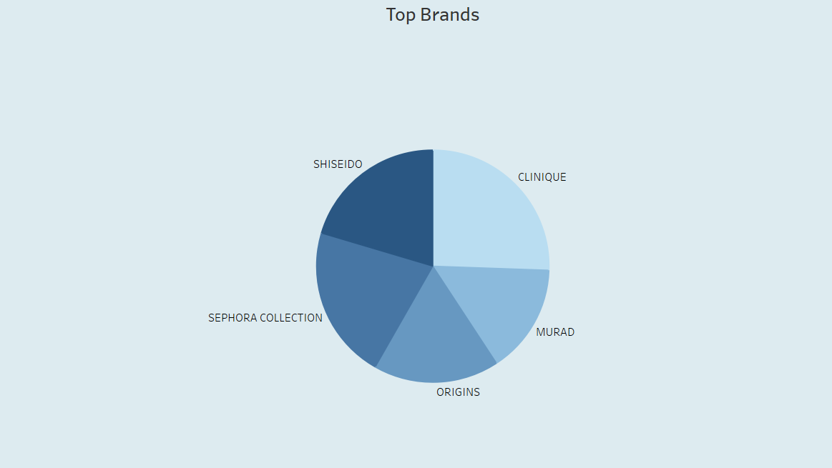

1. **What is the distribution of skincare product types by label count?**

* *Visualization:* Histogram showing the count of skincare product labels, with Moisturizer having the highest count, followed by Cleanser, Face Mask, Treatment, Eye Cream, and Sun Protect.
* Screenshot:

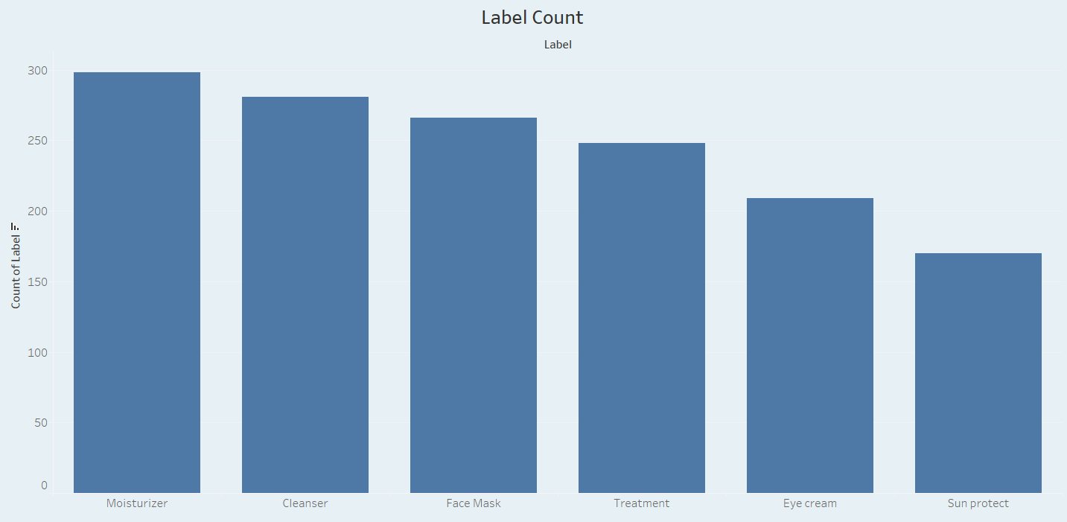

1. **How does the price distribution vary across different beauty brands?**
   * *Visualization*: Box plot illustrating the price distribution of beauty brands, showing a wide range with most prices clustering between 1000 and 2000, and outliers extending up to 5500.
   * *Screenshot of visualisation*

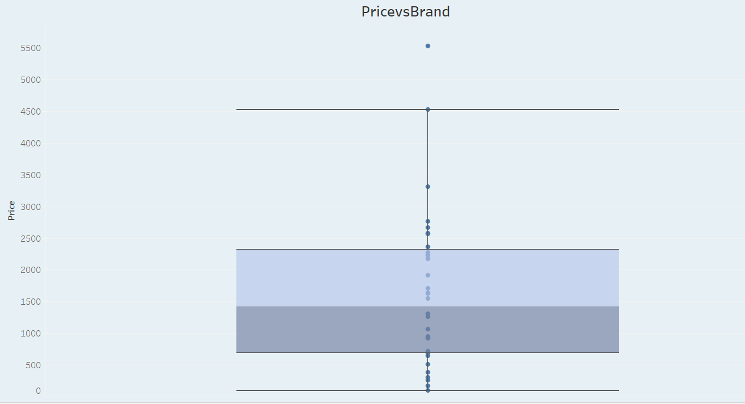

1. **Which beauty and skincare brands have the highest rankings in the BrandvsRank comparison?**

* *Visualization*: Histogram showing the ranking distribution of beauty and skincare brands, with each bar representing a brand's rank on a scale from 0 to 180.
* *Screenshot of visualisation*

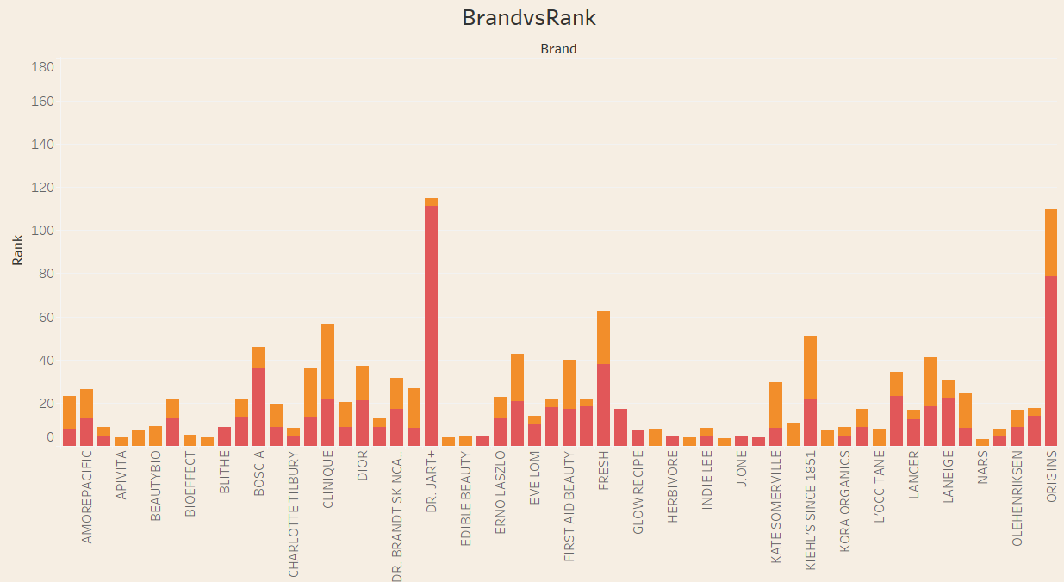

1. **Which beauty brands are most associated with sensitive skin sustainability?**

* *Visualization*: Histogram comparing the sensitive skin sustainability scores of beauty brands, with each bar representing a brand's score on a scale from 0 to 22.
* *Screenshot of visualisation*

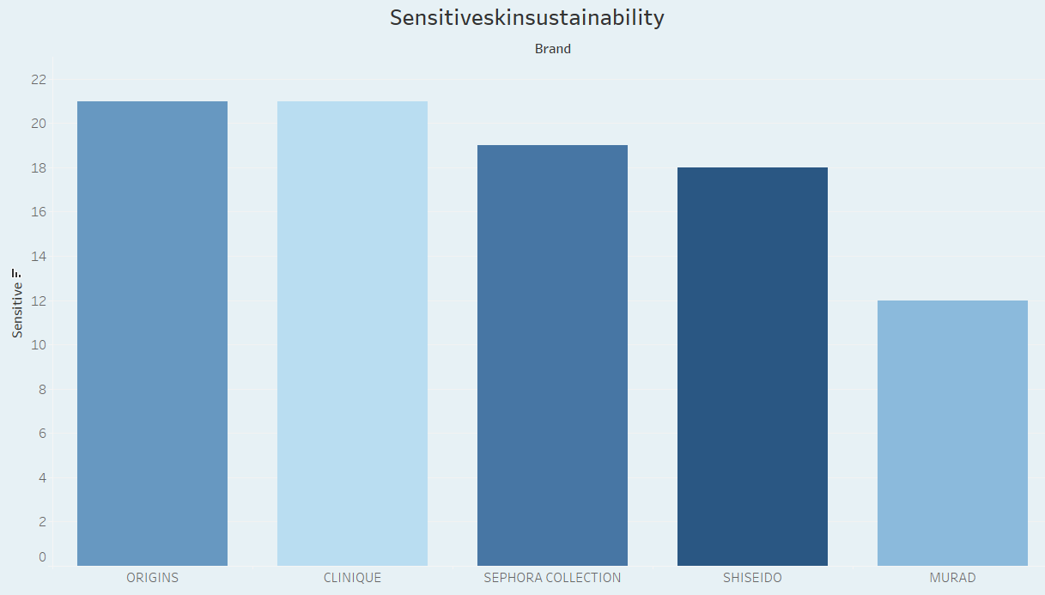

1. **Which beauty brands are most associated with dry skin sustainability?**

* *Visualization*: Bubble chart illustrating the association of beauty brands with dry skin sustainability, with bubble size indicating the strength of association.
* *Screenshot of visualisation*

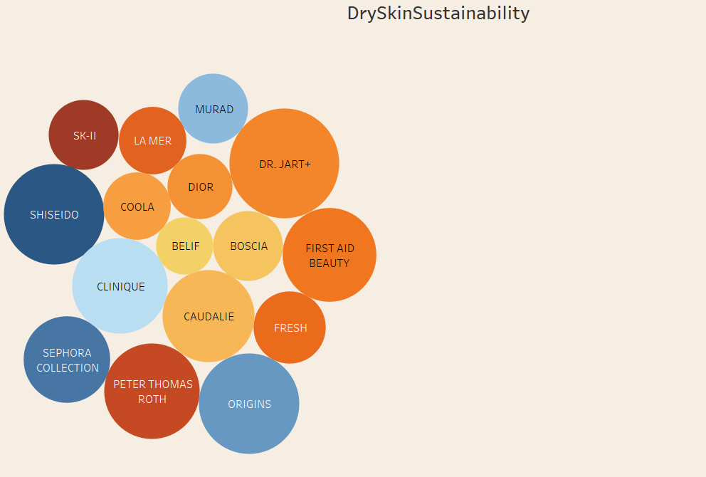

1. **What is the distribution of normal skin sustainability scores across beauty products?**

* *Visualization*: Box plot displaying the distribution of normal skin sustainability scores, with the median, quartiles, and outliers.
* *Screenshot of visualisation*

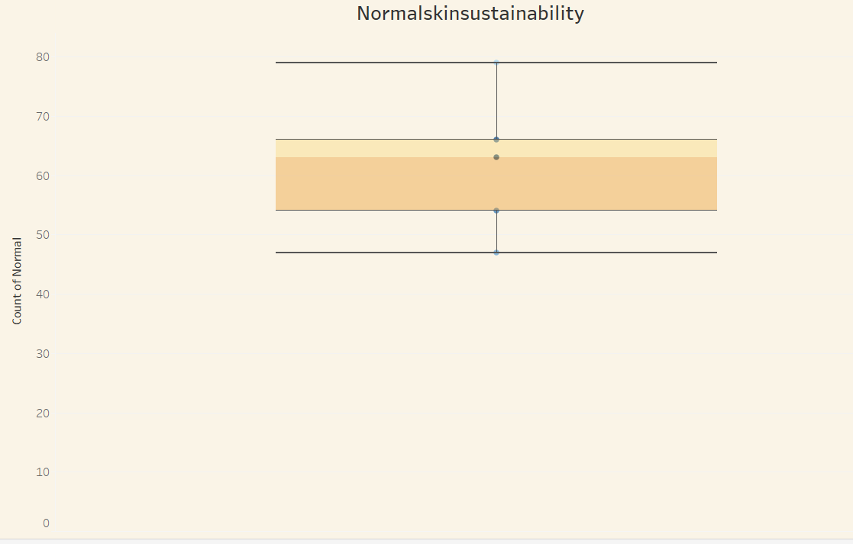

1. **How do different skincare product categories compare in terms of oily skin sustainability?**

* *Visualization*:Stacked bar chart showing the distribution of oily skin sustainability across various skincare product categories, with each bar representing a category's total count.
* *Screenshot of visualisation*

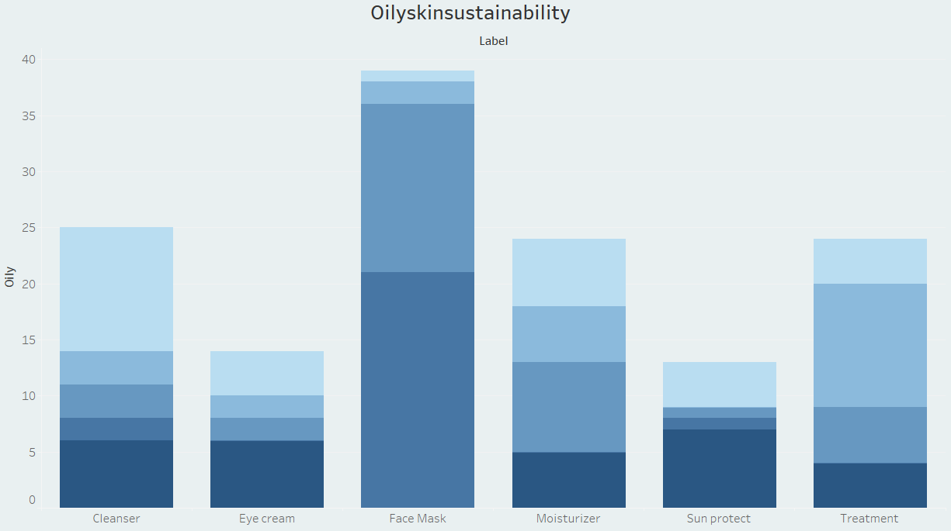

1. **How do different skincare product categories rank in the LabelvsRank comparison?**

* *Visualization*: Stacked bar chart showing the ranking distribution of skincare product categories, with each bar representing a category's total rank.
* *Screenshot of visualisation*

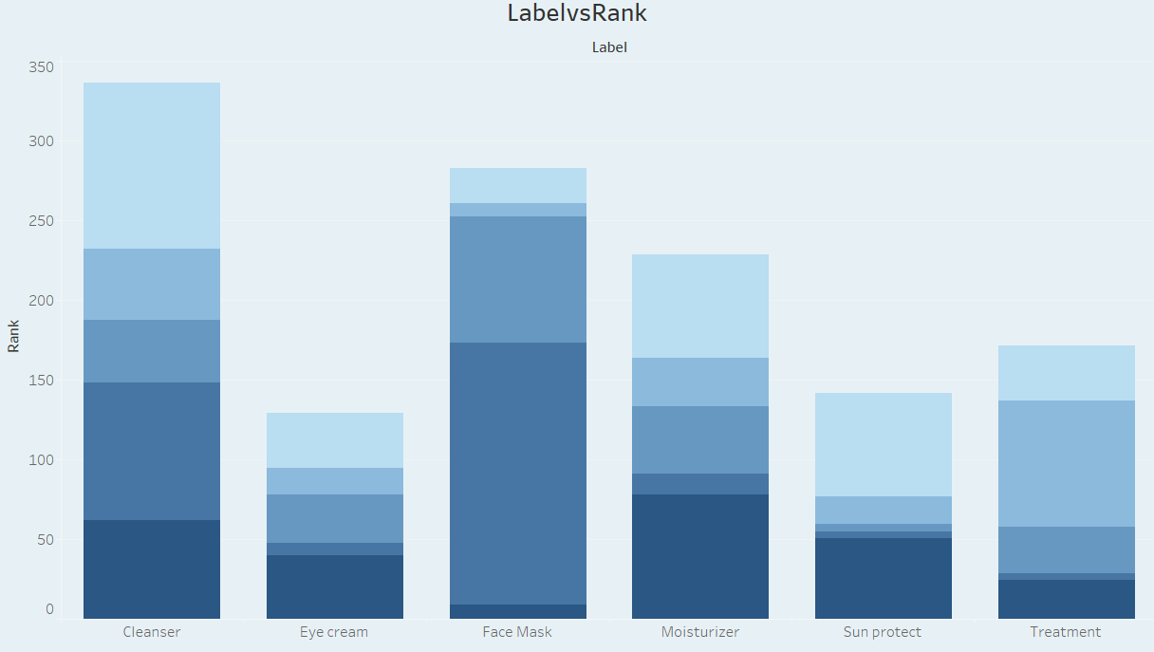

**Note:** Min 8 business question and visualisations Required inform of above